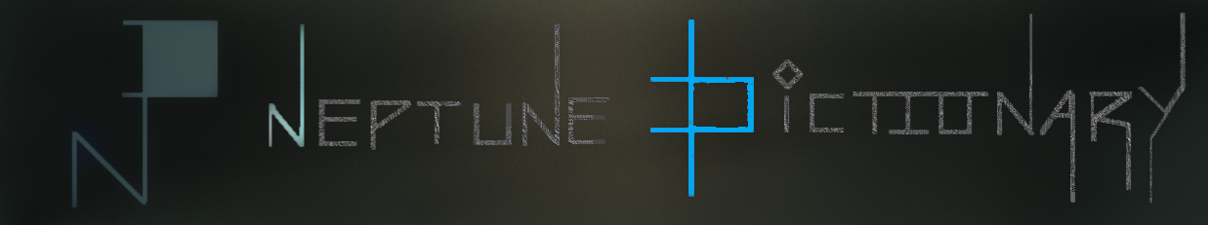

English to Urdu translator

**Created By:**

Ahmed Hasan L16-4027

Shaheryar Ali L16-4305

Haider Baig L16-4142

**Purpose**

This brief report is written to introduce our project design. We are working on a user friendly English to Urdu dictionary.

**Layout**

The layout consists of a title banner with a logo image, menu and side borders. The icon is linked to the main page. The side borders are to keep the focus of the user on the center where the content on a wide screen. Since the mobile layout is already longer than broad so it won’t have the side borders. The menu allows the user to move to either home or about page.

**Pages**

1. Home Page

The main page consists of nothing but a search bar initially. On searching, the results appear below in form of boxes, with English word on left and Urdu translation on right. Clicking on it will take you to the detail page. Also in case of more results that could be displayed on page without scroll, the option to navigate to next page will appear on next page will appear on side borders where clicking on button on right border will take you to next page while clicking on left will take you to previous. We are using this instead of scroll so that user can easily see what results are on the page without having to scroll to bottom of page to see if word is there and then navigate to next page. In mobile version, the layout will have no side borders.

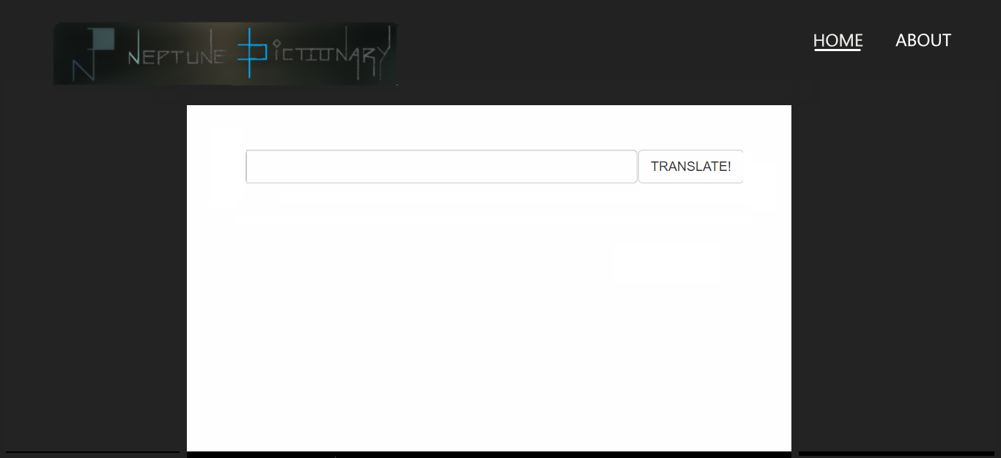

1. Detail Page

The detail page has the English word and translation on the left and urdu translation and meaning on right.

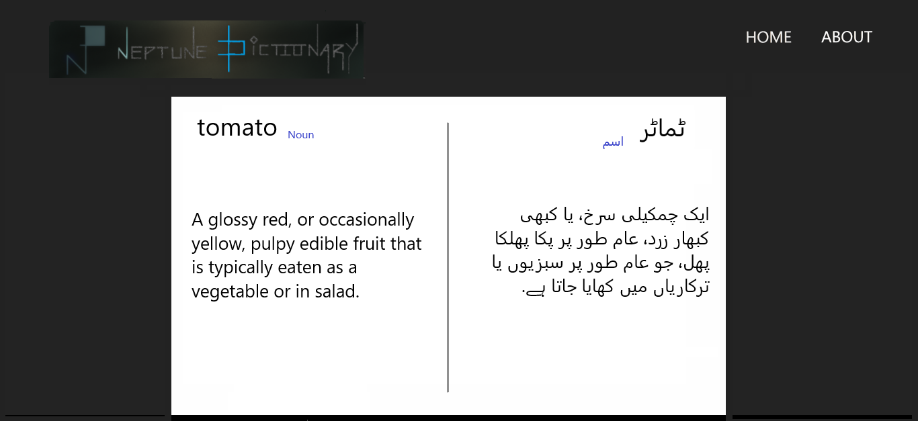

1. About Page

A page that tells about the project and provide contact to creators

